**Coffee Data Analysis (Excel)**

**Clean the Dataset and Populate Orders Data Table.**

*Populate the missing data in the orders sheet.*

* Use XLOOKUP function to fill up the missing data in the orders sheet (Customer Name, Email and Country). Complete the data with information from the customers and products sheets.

=XLOOKUP(C2,customers!$A$1:$A$1001,customers!$B$1:$B$1001,,0)

* Repeat the process with the “Email” & “Country” Columns.
* The Email column has missing values. So instead of getting “0” as a result for the missing values, we add an IF statement to the XLOOKUP formula to retrieve those missing values as they appear on the customer sheet.

=IF(XLOOKUP(C2,customers!$A$1:$A$1001,customers!$C$1:$C$1001,,0)=0,"",XLOOKUP(C2,customers!$A$1:$A$1001,customers!$C$1:$C$1001,,0))

* Country column:

=XLOOKUP(C2,customers!$A$1:$A$1001,customers!$G$1:$G$1001,,0)

* For the Coffee Type, Roast Type, Size and Unit Price columns, we use another formula to make it more dynamic and be able to drag across to other cells. Using the INDEX and MATCH formulas as populate the missing information:

=INDEX(products!$A$1:$G$49,MATCH(orders!$D2,products!$A$1:$A$49,0),MATCH(orders!I$1,products!$A$1:$G$1,0))

* Calculating the Sales and populating all the information in the column using a basic operator:

=L2*E2

* Formatting the Coffee Type Name and Roast Type Name to show full names and not abbreviations:

=IF(I2="Rob","Robusta",IF(I2="Exc","Excelsa",IF(I2="Ara","Arabica",IF(I2="Lib","Liberica",""))))

=IF(J2="M","Medium",IF(J2="L","Light",IF(J2="D","Dark","")))

*Then we do some formatting to customize the table and make it look nicer.*

* Format the Date column to “dd-mmm-yyyy”:
* Select the date column array and customize the date: Select CUSTOM, and type “dd-mmm-yyyy”.
* Format the Size column to show the kgs with 1 decimal point and add “kg” beside it too.
* Select the Size column, press ctrl+shift+down to select the entire column, then ctrl+1 to format it, and select CUSTOM, and type “1.0 ‘kg’”.
* Add $ signs to the Sales and Unit Price Columns by selecting the array and pressing the $ (USD) icon on the ribbon.

*Check for duplicate values in the sheet and eliminate duplicates.*

* Select a value in the table and press ctrl+A to select the entire table. Then in the Data tab on the Ribbon select the option in Data tools called “Remove Duplicates”.
* **Create a table to make it look nice , select all the table and ctrl + T.**

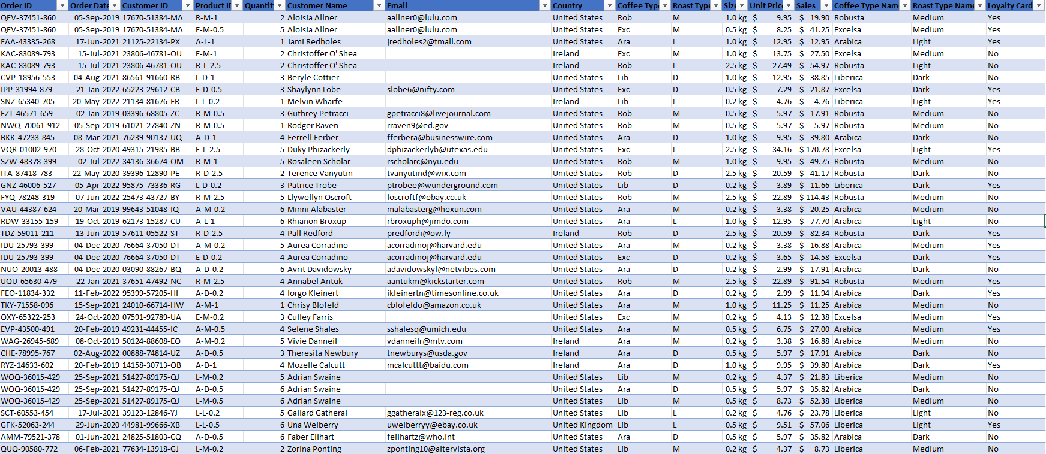

**Analysing the Data with Pivot tables.**

*TOTAL SALES PER YEAR/MONTH*

* Select the Orders table and insert a pivot table in a new sheet.
* Add OrderDate to rows, then right click on the output and select group. Then only request the output of years and months only.
* Go to the Design tab to format the design of the pivot table. In the ribbon select Report Layout , and then I opted for a Tabular format.
* Then Remove both grand totals and subtotals.
* Add Coffee Type Name to columns, and Sales to values (Change the format to number with thousands separator in the value field settings).
* Once the table is done, I proceed to build the graphs.
* Insert a line graph for the pivot table. Customize the format of the line graph to make it look nice by adding titles to the axis, and the graph itself. I also added colours.
* Then I added a timeline to be able to select different periods to analyse the information in the graph.
* I customized and made a new format for the timeline slicer.
* Then add 3 slicers for Size, Coffee Type and Loyalty Cards (Add this new column first in the orders data sheet).

*TOTAL SALES PER COUNTRY*

* Ctrl + Drag Sheet to duplicate and build a new pivot table. In this Pivot table I want the values for total sales and countries in rows.
* Then I insert a bar chart and customize it by sorting the order of the bars from highest to lowest, adding colour and borders to the bars, and reshaping the chart to look nice.

*TOP 5 CUSTOMERS*

* Again drag and drop the sheet to copy the previous pivot table. Now Add the Customer Name instead of country in rows, and select the option to limit to 5, and sort by highest to lowest.
* Add a bar Chard and customize the colours and sizes to make it look like the rest of the charts in the spreadsheet.

**Building the Dashboard**

* Create a new Sheet to build the dashboard.
* I inserted a shape and used shortcuts such as Alt key to shape it perfectly into the cells.
* Customize colours and font for the shape and add titles.
* Customize row height and column widths to use as separators between charts and boxes used in the dashboard.
* Ctrl + X to cut all graphs and ctrl + V to paste the charts in the dashboard sheet.
* Rearrange the charts to give it a good nice, finished look by adding spacing in between and making it appealing to work with.
* Finally, I make sure to connect all charts to each other, by reporting connections and ticking all charts in the timeline and slicers.
* Remove gridlines for a nice finish.

